DataScience Project Repot

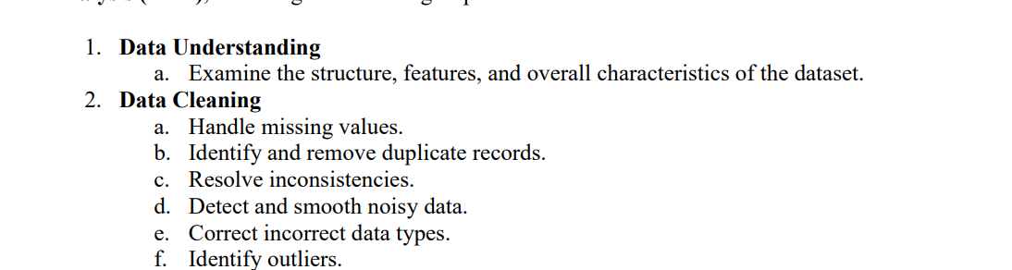
Ahmad Essawii – 12429664

Mojahed alkyyal – 12400763

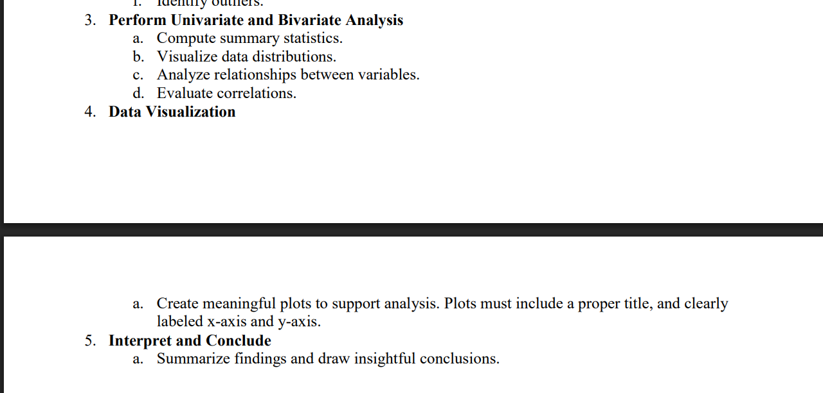

Work Together:
a

+ PowerPoint

